**Hardware Review 1**

**Team 20F03 Malawi**

**ME 486C- 007**

**Husain Aldawood**

**Connor Schmerfeld**

**Hope Williams**

**Shi Zhang**

**February 12, 2021**



**Project Sponsor/Faculty Advisor/Sponsor Mentor:** Dianne McDonnell

**Instructor:** David Trevas

**INTRODUCTION**

Below contains a short memo of Team Malawi's progress since last semester (ME 476C) and our plan for the next four weeks. It also includes our up to date SolidWorks model of the design and a rough Gantt chart to follow to ensure the team stays on track.

**PROGRESS MADE SINCE ME 476C**

One thing the team has made more progress on this semester is the design of the basket underneath the cart. This basket will hold the motor and two batteries that will run the device. Though the team is still unsure how we will attach the basket to the cart, we have figured out the dimensions and materials of the basket. The total length of the basket will be 36” (the same width as the cart), the width of the basket will be 12”, and the height will be 7”. Below in figures one and two is a rough sketch of the basket with a comparison to the cart.

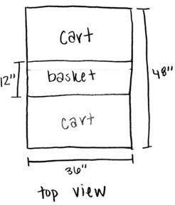 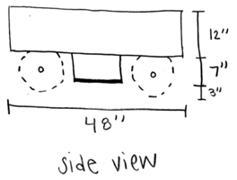

Figure 1: Top View of the Cart with Basket Dimensions Figure 2: Side View of the Cart with Basket Dimensions

The client has informed us that she would like us to use the material 80/20 Aluminum for as much of the cart as we can. 80/20 Aluminum is lighter than regular Aluminum and because she will be traveling to Malawi with the prototype we design, she wants it as light as possible. The team has also decided to attach the basket to the cart, by molding, sliding, or hinging it to the cart, with eight separate posts of dimensions 6”x 6”x 1”. The basket will also have a 1” base at the bottom to cover the bottom of the basket. These dimensions fit the motor and both batteries with a little extra wiggle room. Rough sketches of the basket dimensions can be seen below in figures three and four.

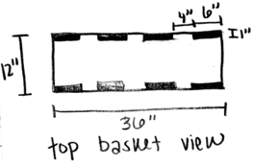 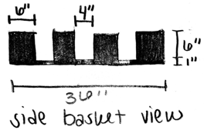

Figure 3: Top View of the Basket Dimensions Figure 4: Side View of the Basket Dimensions

Another thing that the team made progress on is the two batteries needed to run the electrical motor. The batteries we decided on last semester were two 12 volts and Dakota lithium batteries that each battery has a capacity of 7 amp-hours. However, due to Covid-19 shipping delays from the Dakota website, we decided to get the closest available option we found on Amazon, which is two Dakota lithium 12 volts batteries that each battery has a capacity of 10 amp-hours. The new option of batteries have a larger capacity with a bit more expensive price but within the budget. The larger capacity of the batteries would allow us to operate our machine longer, which is a big advantage to these batteries. Figure 5 below shows a picture of the new battery that indicates the capacity and voltage of the battery. Furthermore, the team made a change to the supplier of the batteries’ charger since the supplier we decided on last semester, the Dakota website, has the same issue with shipping the charger. The charger we found on Amazon that is the best for our choice of batteries is a 12 V and 3 Amps charger, which can fully charge each 10 amp-hour battery we have within 3.3 hours. The charger can be seen below in figure 6.

Figure 5: 12 V Dakota Lithium Battery [1] Figure 6: 3 Amps Lithium Battery Charger [2]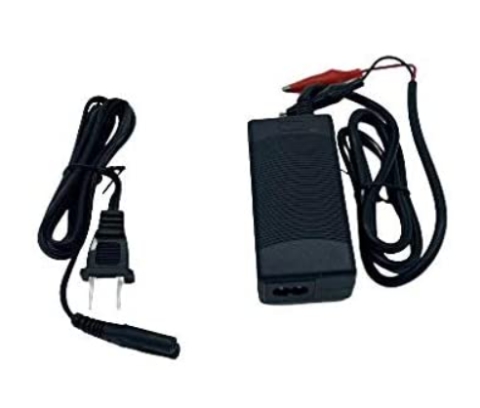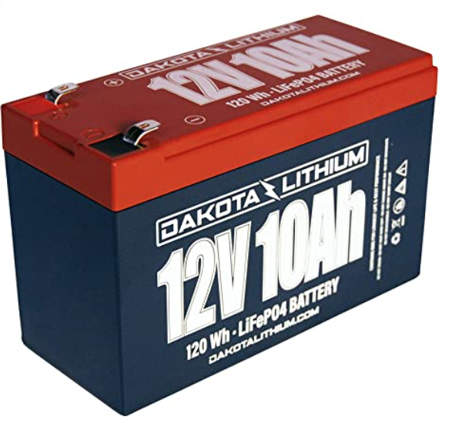

The team also made progress on the pulling and steering mechanism of our machine. We decided to use a utility handle that is used for Gorilla carts and utilize it to steer our cart design. Figure 7 below shows the Gorilla cart handle we are using. The handle is not only going to be used for the human-propelled part of our design, but also we are using it to mount the electrical motor controller on it. The motor controller will be mounted on the handle as a throttle grip, where the operator of the device can pull the cart and/or move the cart using the electrical motor. The handle will also be used to steer the front wheels, where it will make it easier for the operator to steer it considering the large size of tires it has. The tires have a size of 10 inches where they will be mounted on also 10 inches rims, where it will make the whole wheel in the front axle to have a size of 20 inches, figure 8 below shows the tire we are using. The gorilla cart handle we are using can steer the big tires we have easily due to the steel material the handle is made of. This mechanism can ease the controlling of our device and make it user friendly for the operator.

Figure 7: View of the Gorilla cart handle [3] Figure 8: View of the tire chosen [4]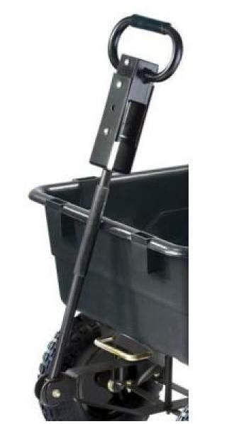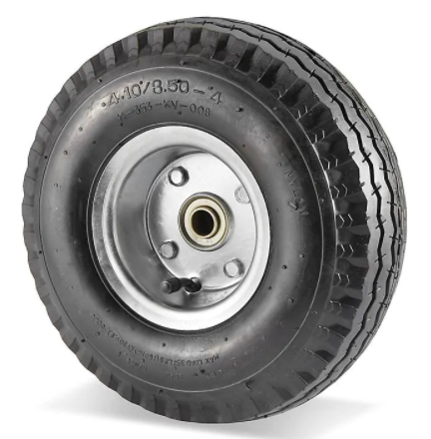

Besides, the team has made progress on the dumping mechanism of our machine. We decided to use a hydraulic bottle jack to lift the cart. As mentioned before, in the improvement of the overall frame of the design, the team has added a basket underneath the cart. The hydraulic bottle jack will be fixed on the basket. By jacking up one side of the cart, the cart will realize dumping on the other side. As shown in figure 9, this bottle jack is compact to lift 8 Ton loads even in tight spaces. The base is made of rugged steel which allows the whole bottle jack to be stable. It can lift up to 16000 lb. as high as 17-5/8 in. Also, the extension screw allows low pickup height adjustment and maximum lift height. Because of the moment, the team doesn't need a 20-ton hydraulic bottle jack, which is much more than the load required. Therefore, the team decided to use an 8-ton hydraulic bottle jack.

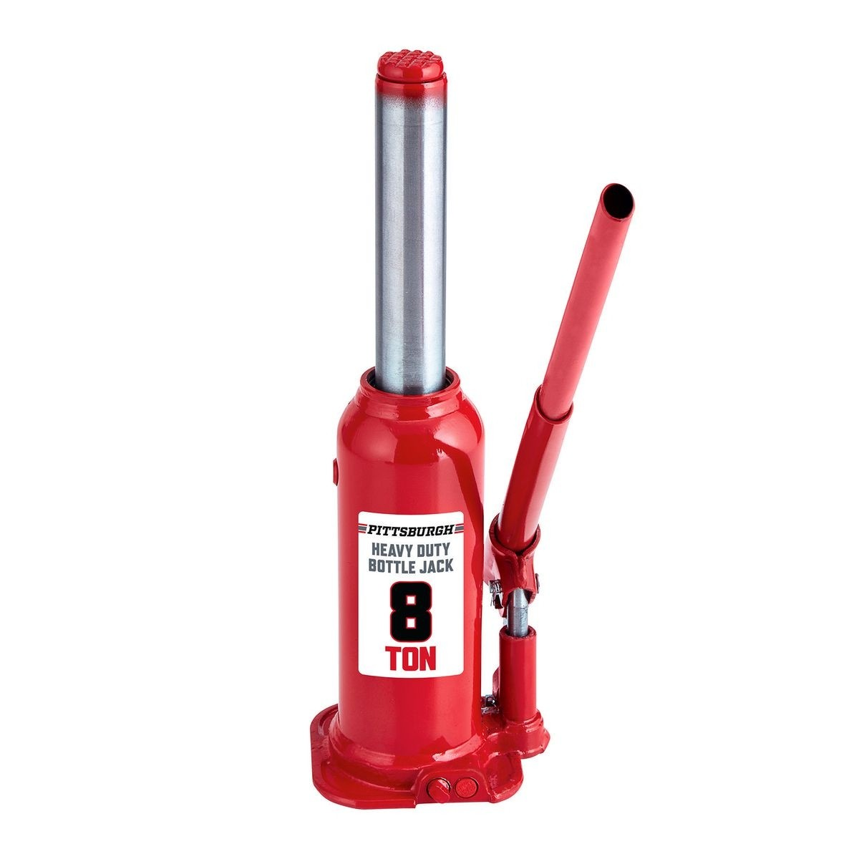

Figure 9: 8 Ton Hydraulic Bottle Jack [5]

To lift the jack, place the lower portion of the handle over the release valve, turn the handle clockwise to close the release valve once the jack is fully lowered. Then place the handle in the fulcrum and pump until the top of the jack's saddle has reached the lifting point. To lower the jack, move the handle to the release valve and turn the handle counterclockwise. The whole operation process is very simple, which is very friendly to the operator.

The last major component that has seen progress thus far is the motor system. Since ME476C, the team has acquired the DC motor that will be used to assist the operator. The motor that was purchased came with a speed controller as well as the twist-throttle handle to actuate the motor. The kit also came with an option key to turn the motor on and off when needed, which will most likely be used in the final build. Pictures of each component can be seen below with further details of each following.

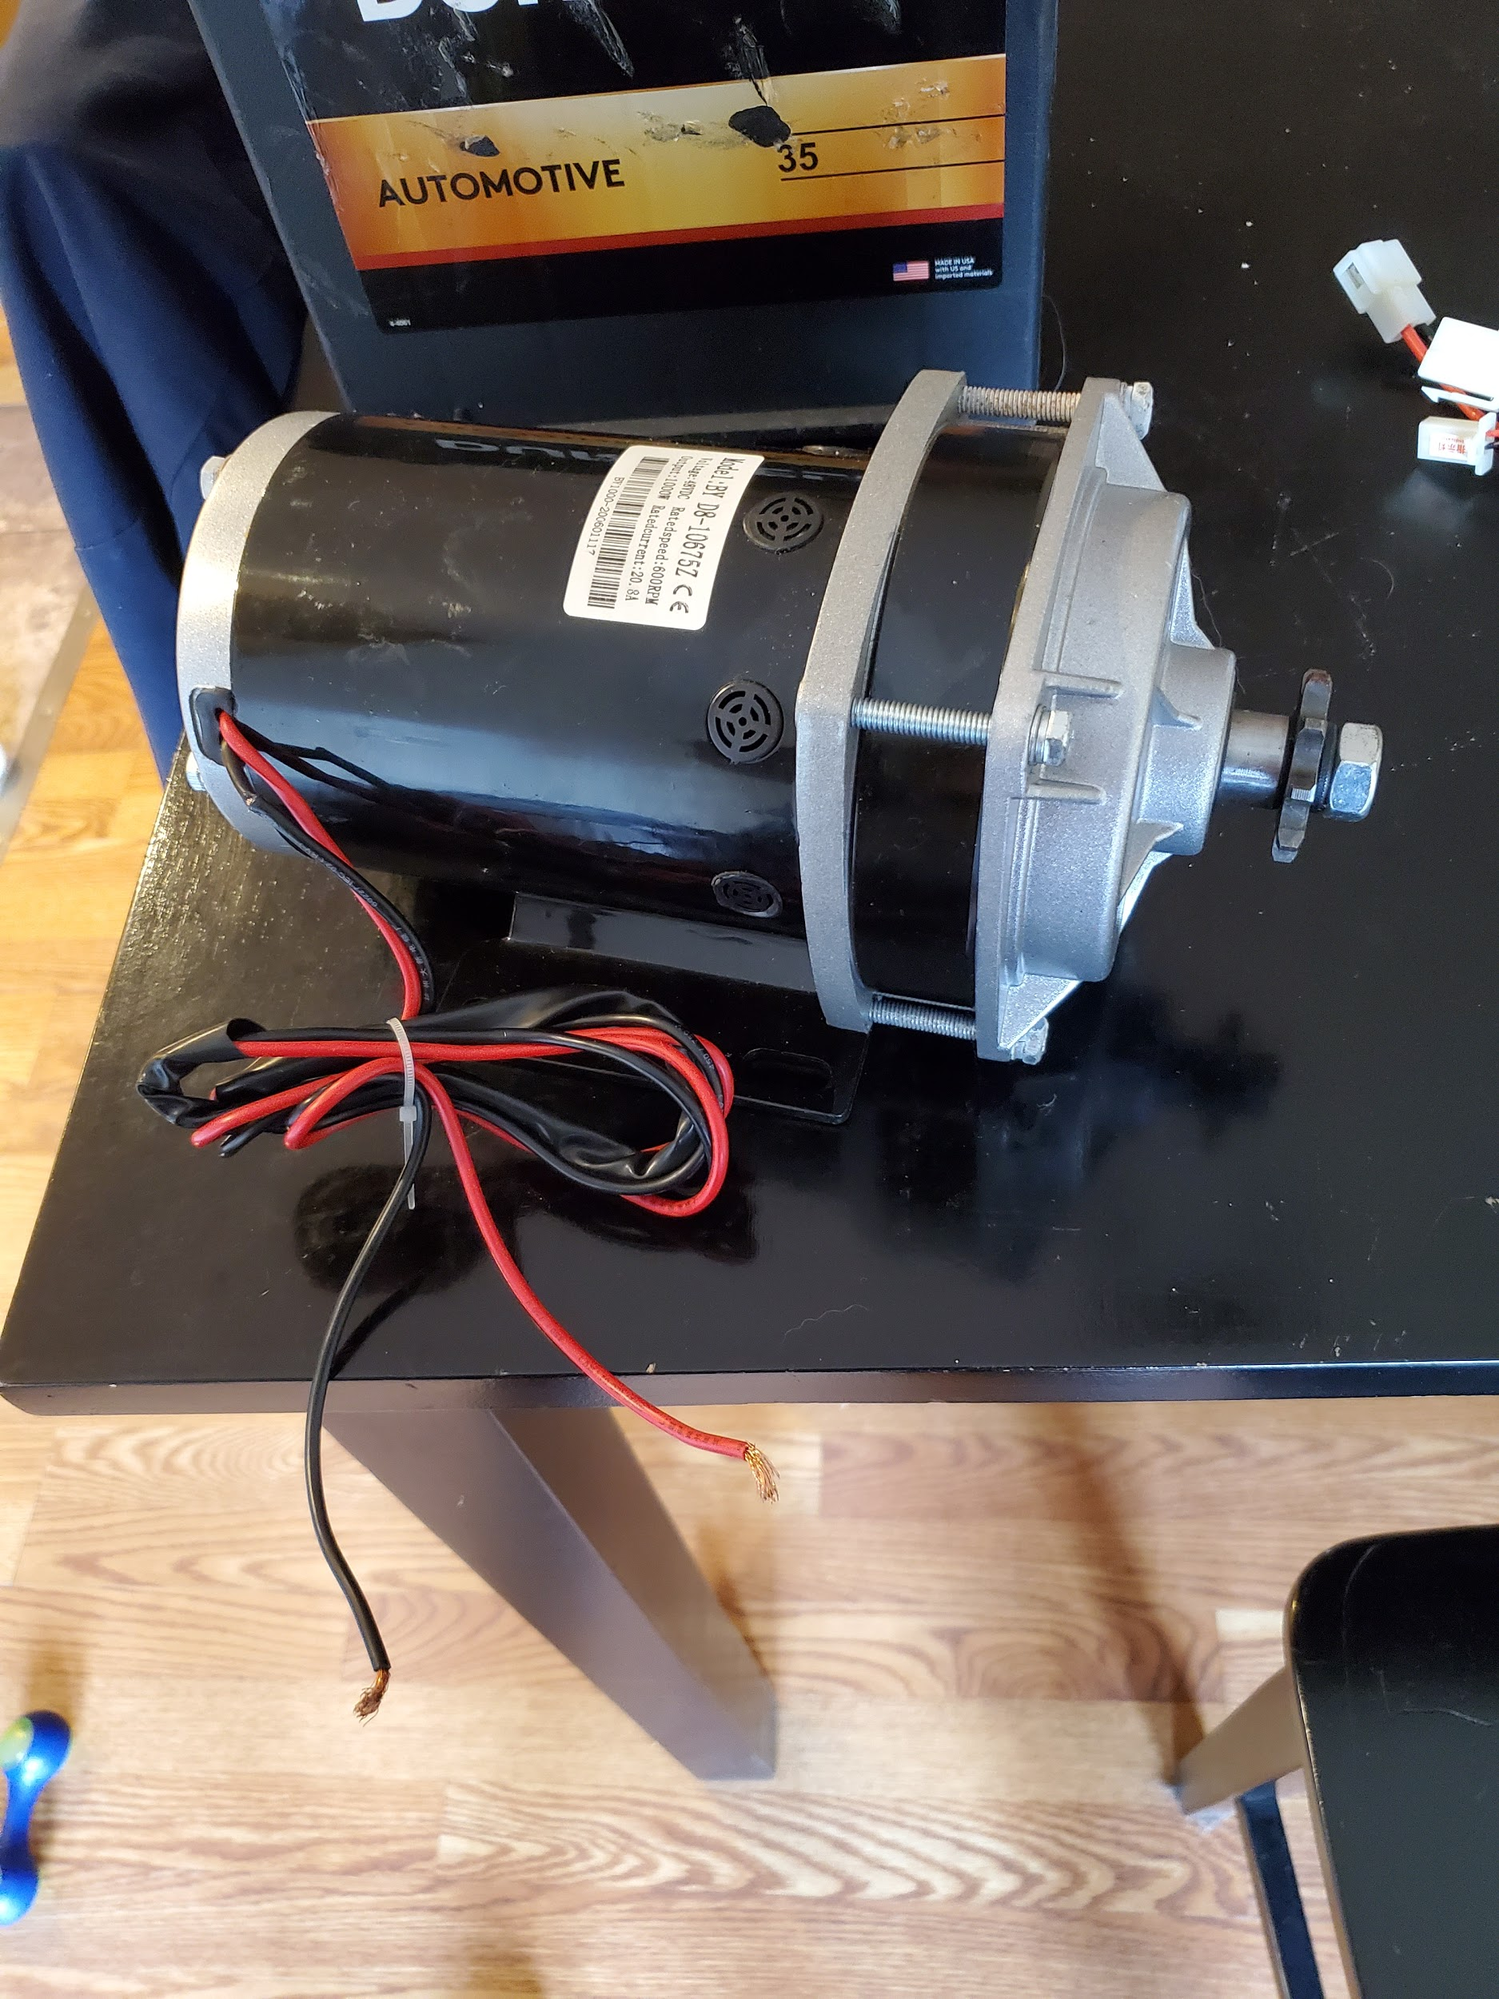

Figure 10: DC Motor

As seen above, that is the motor that will be used in the construction of the design. It is rated at 1,000 Watts and 600rpm. Through further testing, it was found that the standard speed was closer to 200 rpm, which in turn makes it slightly easier to find a proper gear ratio to fit the desired speed. The battery is also rated for up to 48V but has proven to work with a 12V battery as well, so the group decided that it would be best to start at 24V and go up if needed.

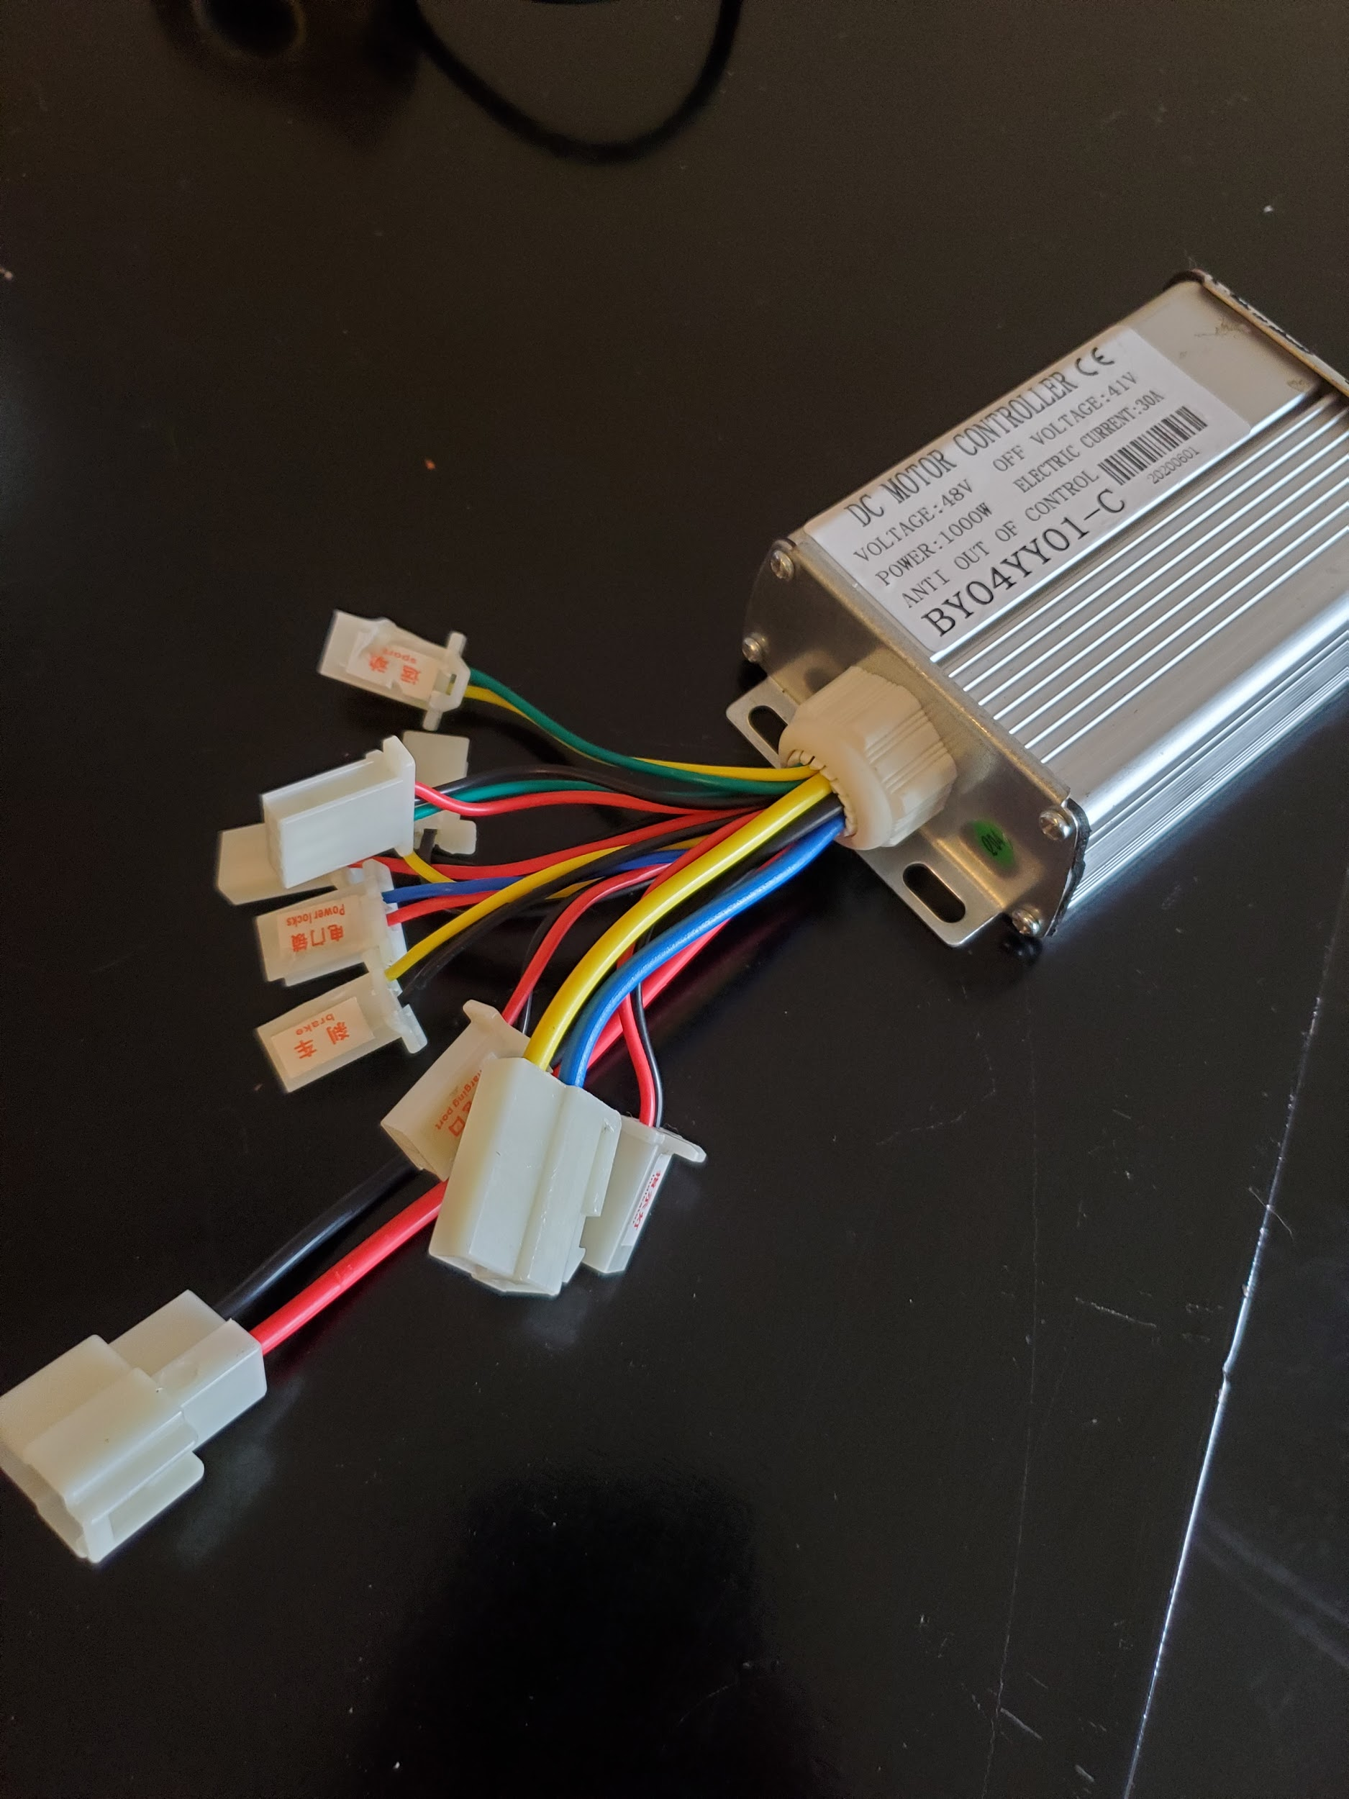

Figure 11: Speed Controller

The speed controller shown above is the device that will act sort of as a switch between the battery and the motor. While it looks complicated, this build will really only need 4 of the connectors: one for the throttle, key, motor, and battery. Each of these will connect into this device in order to be used properly so that the battery doesn’t have a constant drive. The device allows it so that the motor won’t turn if both the key and throttle aren’t on.

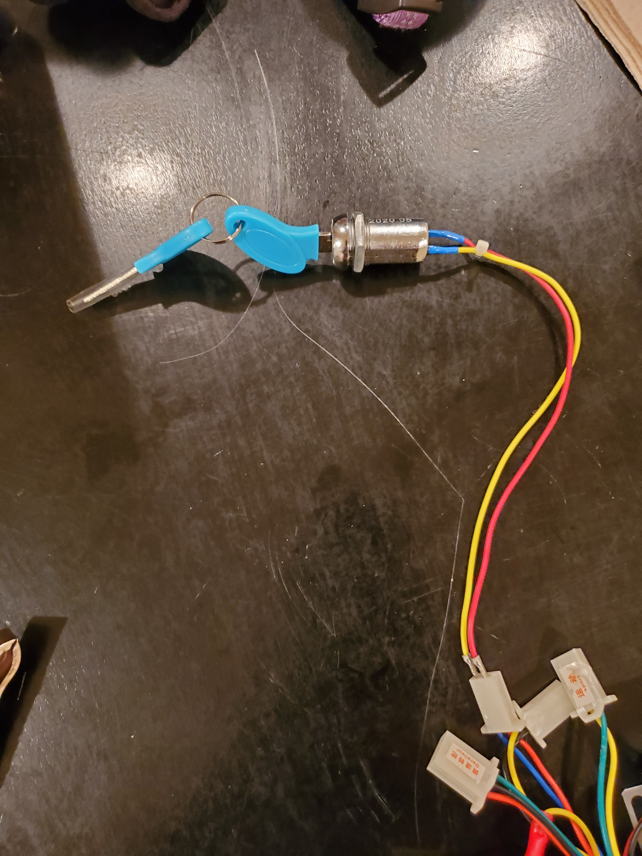

Figure 12: Key Piece

Above is the piece that that key would go into. Shown in the picture also is how that piece would connect to the speed controller. The key could be turn in order to activate the controller before the throttle will allow the motor to move.

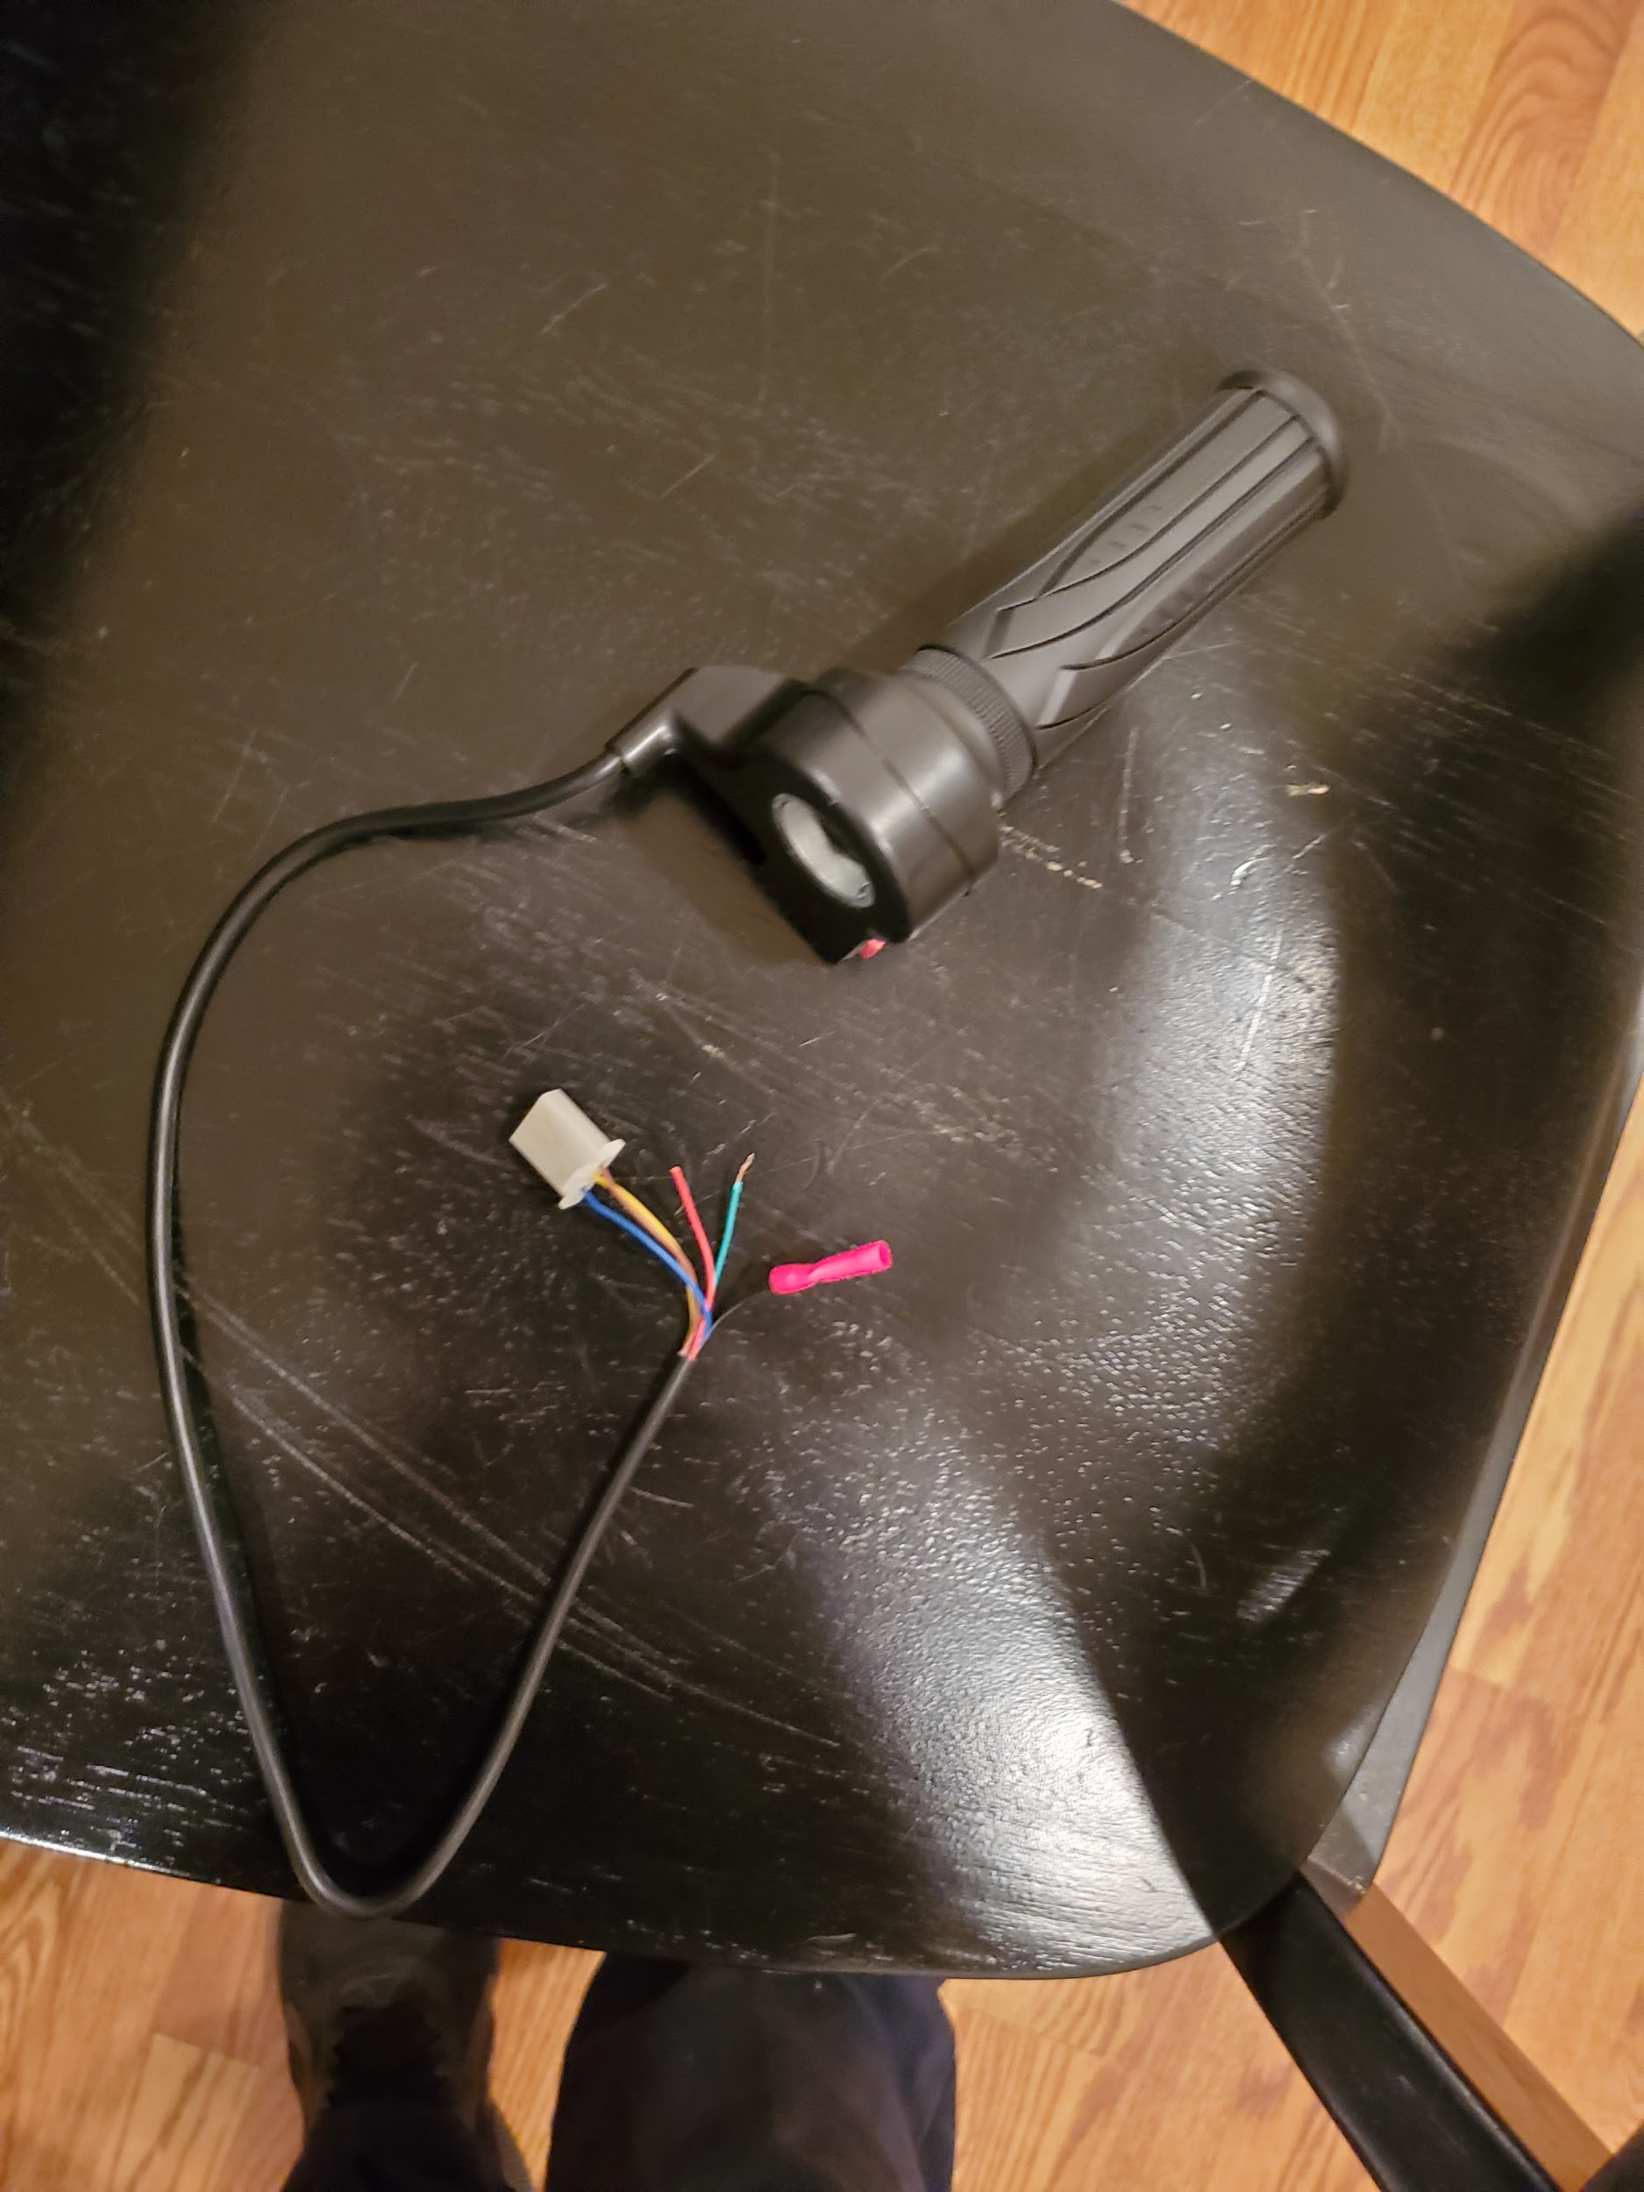

Figure 13: Twist throttle

The above photo shows the twist throttle controller for the motor. The wires connected will also connect to the speed controller in order to control when the motor can be activated. The handle piece of this device will be a part of the handle discussed above. Certain cuts in the handle may be made in order to accommodate the grip so that it can be used properly. As of now, all of these components are in the process of being connected properly by the team in order to begin testing. Testing will include finding proper gear ratio and seeing how different loads affect the speed of this motor.

**PLAN BETWEEN NOW AND HARDWARE REVIEW 2**

As of now, the team has ordered the motor, tires, 80/20 Aluminum material, and jack for the device. So far only the jack and motor have come in and are in the team's possession. The team has also been informed the tires for the device were signed off at the engineering building on 11/18/2020 and we are currently looking for them. The team also tried to make a purchase of the batteries we picked out, but due to COVID-19, the earliest they can be shipped is in the middle of March. The team is now in the process of looking for batteries from a different supplier. Until the battery situation has been figured out, the team will continue tests with standard lead-acid car batteries, but this will not be a part of the final build.

**PHOTOS OF THE CURRENT STATE SYSTEM**

Below are pictures of the current SolidWorks design. This was the design that was approved by the client, Dr. McDonnell. In the photos, each major component can be seen together in order to demonstrate how the project will function.

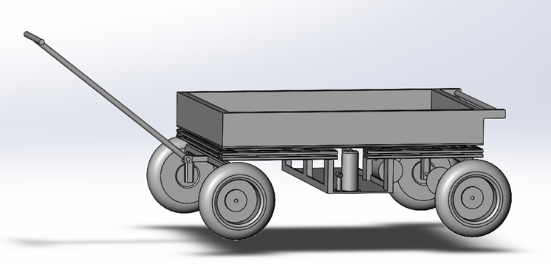

Figure 14: Side view of the design, illustrating the placement of the hydraulic jack on the basket piece and how the handle will attach to the front axle..

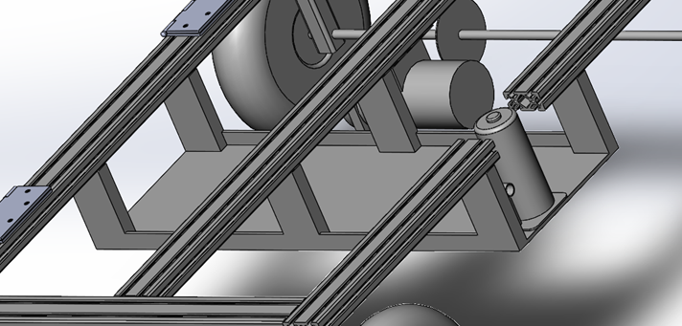

Figure 15: A better view of the basket and how it will connect to the 8020 framing.

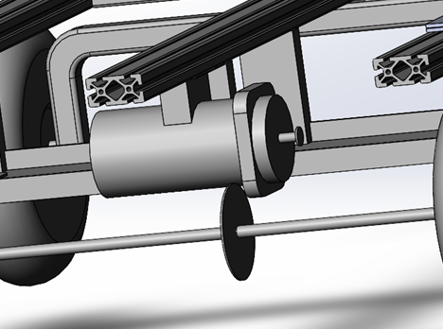

Figure 16: A close up view of the motor and how it will attach to the framing.The sprocket can be seen on the rear axle as well.

**CONCLUSION**

In conclusion, the team is very close to beginning the building process. Many components are also in that can be tested on. The team is planning on starting on the bucket of the project in the coming weeks in order to start the weight testing. Furthermore, once the tires are in, a proper axle can be determined and placed on as well. Another plan in the coming week is to order a proper sprocket that can deliver a proper speed to the rear wheels through a chain. The basket will also be built in the coming weeks and this will allow for the jack to be placed to help test the dumping mechanism of the build with the bucket once it is constructed. There is still much to do, but these next weeks will be the main construction of the build as long as everything arrives accordingly.

**REFERENCES**

[1] Dakota Lithium, “12 Volt Rechargeable Lithium Battery,” Amazon, 08-Apr-2014. [Online]. Available:https://www.amazon.com/12-Volt-Rechargeable-Lithium-Battery/dp/B00JK06CK8/ref=sr_1_23?crid=38SDASTEVF4TV&dchild=1&keywords=12v+7ah+lithium+battery&qid=1613092043&sprefix=12V+7AH+Lithium+%2Cautomotive%2C211&sr=8-23.

[2] Dakota Lithium, “12V 3 Amp LiFePO4 Battery Charger,” *Amazon*, 27-Dec-2018. [Online]. Available:https://www.amazon.com/Dakota-Lithium-Batteries-Battery-BATCHAR1/dp/B07MHP8653/ref=sr_1_5?dchild=1&keywords=Lithium%7C12V+7Ah&qid=1613091543&s=automotive&sr=1-5.

[3] Gorilla Carts, “GORILLA CARTS Replacement 2-in-1 Utility Handle-GOR-HDL-DOS,” *The Home Depot*. [Online]. Available: https://www.homedepot.com/p/GORILLA-CARTS-Replacement-2-in-1-Utility-Handle-GOR-HDL-DOS/205034902?source=shoppingads&locale=en-US&mtc=Shopping-B-F_D28I-G-D28I-28_11_TOOLS-MULTI-NA-Feed-PLA-NA-NA-BASE_SHP&cm_mmc=Shopping-B-F_D28I-G-D28I-28_11_TOOLS-MULTI-NA-Feed-PLA-NA-NA-BASE_SHP-71700000041074948-58700004807804150-92700041230804539&gclid=EAIaIQobChMIgK_O8YLe7gIVFz2tBh1-cgobEAQYAiABEgIQtvD_BwE&gclsrc=aw.ds#product-overview.

[4] uline, “Uline Pneumatic Wheel - 350 lb Capacity, 10,’” *Uline*. [Online]. Available: https://www.uline.com/Product/Detail/H-3359/Casters-and-Wheels/Uline-Pneumatic-Wheel-350-lb-Capacity-10?pricode=WA9542&gadtype=pla&id=H-3359&gclid=CjwKCAiA-f78BRBbEiwATKRRBOTYHr605YeasmR5Wc9PY2UGNvXx6xAENMSfFJrTkjTqqwe_8bY7dRoCdAAQAvD_BwE&gclsrc=aw.ds.

[5]"8 Ton Hydraulic Bottle Jack", Harbor Freight Tools, 2021. [Online]. Available: https://www.harborfreight.com/8-ton-hydraulic-bottle-jack-56734.html. [Accessed: 12- Feb- 2021].